Table 1: Variation in root biomass and root length of different maize genotypes as affected by Striga infestation under pot conditions
Genotypes | Dry root biomass (g) |  | Root length (cm) |  | Fresh root biomass (g)
 | Striga-infested | Normal | Striga-infested | Normal | Striga-infested | Normal
CHFB04-OB | 1.06^{bcdef} | 1.25ª | 17.62^{ab} | 21.35^{ab} | 4.56^{bcde} | 4.90a
KPAS04 | 0.60^{def} | 0.85^{abc} | 12.30^{defghi} | 24.05ª | 3.60^{bcdefg} | 4.25^{abc}
OKOMASA | 0.38^{ef} | 0.73^{abc} | 8.92^{ij} | 13.07^{efg} | 1.68^{efg} | 2.93^{abc}
KOBN03-OB | 0.80^{cdef} | 0.43^{bc} | 13.02^{cdefgh} | 14.73^{cdefg} | 3.78^{bcdefg} | 2.40^{abc}
NYAZ03-Y | 0.36^{ef} | 0.47^{abc} | 13.48^{cdefg} | 15.93^{bcdefg} | 2.10^{cdefg} | 2.13^{abc}
NYAZ04-W | 0.45^{def} | 0.53^{abc} | 12.72^{cdefghi} | 21.30^{ab} | 2.31^{cdefg} | 2.40^{abc}
GUMA03-OB | 0.83^{cdef} | 0.40^{c} | 14.28^{abcdefg} | 16.33^{bcdefg} | 4.38^{bcdef} | 2.00^{bc}
GBRM04-BA | 0.18^{ef} | 0.53^{abc} | 7.26 ^{j} | 14.33^{cdefg} | 1.29^{g} | 1.87^{c}
TZE-Y-DT-STR-C4 | 1.17^{bcdef} | 0.43^{bc} | 11.31^{fghi} | 16.37^{bcdefg} | 4.83^{abc} | 2.27^{abc}
DORKE SR | 0.74^{cdef} | 1.00^{abc} | 15.4^{abcde} | 16.75^{bcdef} | 3.38^{bcdefg} | 4.35^{abc}
NYAN03 | 0.42^{ef} | 0.67^{abc} | 12.26^{defghi} | 20.13^{abc} | 2.40^{cdefg} | 3.80^{abc}
TZE-W-DT-STR-C4 | 0.23^{ef} | 0.80^{abc} | 10.79^{ghij} | 13.65^{defg} | 1.62^{fg} | 3.35^{abc}
NYIA03 | 1.11^{bcdef} | 0.50^{abc} | 16.62^{abc} | 18.03^{bcde} | 4.38^{bcdef} | 2.17^{abc}
NYLA04 | 0.90^{cdef} | 1.20^{ab} | 10.77^{ghij} | 16.70^{bcdef} | 4.41^{cdef} | 4.83^{ab}
TAAN04 | 0.51^{def} | 0.33^{c} | 11.31^{fghi} | 12.60^{efg} | 2.22^{cdefg} | 1.77^{c}
NYSW03-Y | 0.09^{f} | 0.53^{abc} | 9.00^{ij} | 13.13^{efg} | 1.02^{g} | 2.77^{abc}
DT-STR-W-C2 | 0.36^{ef} | 0.83^{abc} | 11.67^{efghi} | 20.03^{abc} | 1.59^{fg} | 3.57^{abc}
SISF03-0B | 2.67ª | 0.43^{bc} | 17.79ª | 15.57^{bcdefg} | 7.53ª | 2.03^{abc}
KOBN04-R | 0.35^{ef} | 0.63^{abc} | 9.36^{hij} | 17.73^{bcdef} | 1.83^{defg} | 2.83^{abc}
TAIS03 | 1.86^{abc} | 0.97^{abc} | 15.15^{abcdef} | 14.43^{cdefg} | 5.73^{ab} | 3.30^{abc}
CHMA04 | 1.57^{abcd} | 0.87^{abc} | 13.72^{bcdefg} | 19.47^{abcd} | 4.76^{abc} | 2.70^{abc}
IWD-C3-SYN-F2 | 1.78^{abc} | 0.65^{abc} | 16.20^{abcd} | 10.50^{g} | 5.76^{ab} | 3.90^{abc}
NYFA04 | 0.84^{cdef} | 0.67^{abc} | 14.64^{abcdefg} | 15.47^{bcdefg} | 2.06^{cdefg} | 3.43^{abc}
GH120 DYF/D POP | 2.09^{ab} | 1.10^{abc} | 12.06^{efghi} | 18.40^{abcde} | 4.62^{bcd} | 4.45^{abc}
NYFA03 | 1.25^{bcde} | 0.67^{abc} | 11.82^{efghi} | 11.87^{fg} | 2.74^{cdefg} | 2.57^{abc}
Mean | 0.90 | 0.70 | 12.78 | 16.48 | 3.22 | 3.08
SEM | 0.06 | 0.05 | 0.52 | 0.51 | 0.20 | 0.20
SEM: Standard error of mean; genotypes having the same letters (vertical direction) are not significantly different at 5% level of probability

Table 2: Variation in leaf area and shoot biomass of different maize genotypes as affected by Striga infestation under pot conditions

Genotypes | Leaf Area (cm²) |  | Fresh Shoot Weight (g) |  | Dry Shoot Weight (g)
 | Striga-infested | Normal | Striga-infested | Normal | Striga-infested | Normal
CHFB04-OB | 87.47^{ab} | 136.5^{ab} | 41.32^{bcde} | 85.90ª | 5.32^{bcdef} | 8.95^{ab}
KPAS04 | 82.32^{abc} | 150.7ª | 37.44^{cde} | 88.45ª | 5.34^{bcdef} | 10.20ª
OKOMASA | 68.04^{bcd} | 87.2e | 14.88^{fgh} | 38.93^{bcd} | 2.88^{efg} | 3.97^{d}
KOBN03-OB | 74.40^{abcd} | 113.4^{bcde} | 38.10^{bcde} | 33.27^{cd} | 5.18^{bcdef} | 3.77^{d}
NYAZ03-Y | 59.91^{bcde} | 95.6^{cde} | 23.14^{efgh} | 28.43^{cd} | 3.16^{defg} | 3.30^{d}
NYAZ04-W | 76.83^{abcd} | 106.2^{cde} | 31.00^{cdef} | 41.10^{bcd} | 3.87^{cdefg} | 4.50^{d}
GUMA03-OB | 69.22^{abcd} | 103.7^{cde} | 30.99^{cdefg} | 46.00^{bcd} | 3.75^{cdefg} | 4.37^{d}
GBRM04-BA | 74.68^{abcd} | 89.9de | 11.04^{gh} | 38.77^{cd} | 2.61^{fg} | 4.03^{d}
TZE-Y-DT-STR-C4 | 63.07^{bcd} | 99.6^{cde} | 26.22^{defgh} | 38.50^{cd} | 3.69^{cdefg} | 3.90^{d}
DORKE SR | 73.03^{abcd} | 107.5^{cde} | 40.70^{bcde} | 56.35^{bc} | 5.70^{bcdef} | 6.35^{bcd}
NYAN03 | 84.96^{abc} | 118.47^{bc} | 24.76^{efgh} | 53.43^{bcd} | 3.22^{defg} | 5.53^{cd}
TZE-W-DT-STR-C4 | 67.61^{bcd} | 109.0^{bcde} | 33.12^{cdef} | 68.20^{ab} | 4.83^{bcdef} | 7.95^{abc}
NYIA03 | 68.75^{bcd} | 97.1^{cde} | 47.16^{abc} | 47.40^{bcd} | 6.75^{abc} | 4.63^{d}
NYLA04 | 86.09^{abc} | 104.4^{cde} | 33.36^{cdef} | 43.47^{bcd} | 5.31^{bcdef} | 4.57^{d}
TAAN04 | 68.87^{bcd} | 110.4^{bcde} | 29.07^{cdefg} | 25.67^{d} | 4.08^{cdef} | 3.40^{d}
NYSW03-Y | 33.09e | 115.9^{bcd} | 7.00^{h} | 44.40^{bcd} | 0.63^{g} | 4.97^{cd}
DT-STR-W-C2 | 58.67^{cde} | 100.8^{cde} | 33.78^{cdef} | 55.87^{bc} | 4.11^{cdef} | 6.07^{bcd}
SISF03-0B | 97.57ª | 100.1^{cde} | 57.81^{ab} | 45.60^{bcd} | 9.12ª | 4.60^{d}
KOBN04-R | 83.14^{abc} | 108.9^{bcde} | 26.04^{defgh} | 43.90^{bcd} | 3.33^{defg} | 4.03^{d}
TAIS03 | 72.56^{abcd} | 108.4^{cde} | 63.78ª | 35.90^{cd} | 7.83^{ab} | 3.73^{d}
CHMA04 | 76.52^{abcd} | 111.1^{bcde} | 39.34^{bcde} | 42.70^{bcd} | 6.18^{abcde} | 4.10^{d}
IWD-C3-SYN-F2 | 49.37de | 107.1^{cde} | 40.05^{bcde} | 29.00^{cd} | 6.48^{abcd} | 4.05^{d}
NYFA04 | 73.46^{abcd} | 108.4^{cde} | 27.68^{cdefg} | 45.13^{bcd} | 4.52^{bcdef} | 3.90^{d}
GH120 DYF/D POP | 48.93de | 92.0^{cde} | 45.75^{abcd} | 49.40^{bcd} | 7.68^{ab} | 4.75^{d}
NYFA03 | 79.58^{abc} | 96.3^{cde} | 32.00^{cdef} | 35.80^{cd} | 6.78^{abc} | 4.93^{cd}
Mean | 71.13 | 107.15 | 33.42 | 46.46 | 3.64 | 4.98
SEM | 3.51 | 1.78 | 2.31 | 2.44 | 0.28 | 0.27
SEM: Standard error of mean; genotypes having the same letters (vertical direction) are not significantly different at 5% level of probability

Table 3: Variation in plant height, days to anthesis and days to pollen shed of different maize genotypes as affected by Striga infestation during field screening in the 2013 cropping season

Genotype | Plant height |  | Days to 50% anthesis |  | Days to 50% pollen shed
 | Striga-infested | Normal | Striga-infested | Normal | Striga-infested | Normal
CHFB04-OB | 149.13^{abcd} | 159.27^{abcde} | 58.33^{cde} | 59.67^{cdefgh} | 66.67^{bcd} | 68.00^{abcd}
KPAS04 | 132.77^{bcdef} | 145.87^{defgh} | 58.00de | 60.00^{bcdefgh} | 66.33^{cde} | 68.33^{abc}
OKOMASA | 131.10^{cdef} | 135.33^{efghi} | 61.67^{b} | 64.00ª | 66.67^{bcd} | 70.67ª
KOBN03-OB | 138.53^{abcdef} | 153.57^{cdefg} | 57.67^{def} | 62.00^{abcde} | 65.00^{defgh} | 68.67^{abc}
NYAZ03-Y | 147.83^{abcd} | 162.37^{abcd} | 57.67^{def} | 60.33^{abcdefg} | 65.00^{defgh} | 69.00^{ab}
NYAZ04-W | 149.73^{abc} | 168.23^{abcd} | 55.00^{fg} | 57.00^{ghij} | 66.00^{cdef} | 63.00^{efgh}
GUMA03-OB | 142.67^{abcde} | 174.35^{abc} | 59.67^{bcd} | 61.67^{abcdef} | 67.67^{bc} | 70.00^{ab}
GBRM04-BA | 152.53^{abc} | 172.97^{abc} | 67.00ª | 62.33^{abcd} | 71.67ª | 69.67^{ab}
TZE-Y-DT-STR-C4 | 118.83^{f} | 127.07^{hi} | 53.00^{g} | 55.00^{ijk} | 61.67^{j} | 59.33^{hi}
DORKE SR | 138.40^{abcdef} | 134.80^{fghi} | 58.33^{cde} | 59.00^{defgh} | 66.00^{cdef} | 69.00^{ab}
NYAN03 | 149.83^{abc} | 168.93^{abcd} | 58.33^{cde} | 58.67^{defghi} | 65.33^{cdefg} | 67.67^{abcd}
TZE-W-DT-STR-C4 | 119.33^{f} | 121.00^{i} | 53.00^{g} | 51.33^{k} | 58.00^{k} | 59.00^{i}
NYIA03 | 144.33^{abcde} | 183.10ª | 57.67^{def} | 57.00^{ghij} | 65.33^{g} | 61.67^{fghi}
NYLA04 | 156.03^{ab} | 165.10^{abcd} | 61.00^{bc} | 59.00^{defgh} | 69.00^{b} | 66.33^{bcde}
TAAN04 | 150.53^{abc} | 181.37^{ab} | 58.67^{cde} | 58.00^{fghi} | 65.33^{cdefg} | 66.33^{bcde}
NYSW03-Y | 131.43^{cdef} | 169.23^{abcd} | 53.00^{g} | 54.00^{jk} | 58.67^{k} | 61.00^{ghi}
DT-STR-W-C2 | 129.53^{cdef} | 129.67^{ghi} | 57.00^{def} | 63.67^{ab} | 64.00^{efghij} | 70.00^{ab}
SISF03-0B | 130.63^{cdef} | 157.90^{bcdef} | 57.67^{def} | 56.33^{hij} | 65.00^{defgh} | 63.00^{efgh}
KOBN04-R | 132.10^{cdef} | 165.50^{abcd} | 56.67^{ef} | 55.00^{jk} | 63.67^{fghij} | 64.33^{g}
TAIS03 | 150.03^{abc} | 148.70^{defgh} | 57.00^{def} | 60.33^{abcdefg} | 63.33^{ghij} | 67.00^{abcd}
CHMA04 | 160.03ª | 169.63^{abcd} | 59.00^{bcde} | 63.00^{abc} | 67.00^{bcd} | 69.67^{ab}
IWD-C3-SYN-F2 | 125.90^{def} | 131.00^{ghi} | 56.67^{ef} | 58.33^{fghi} | 62.33^{ij} | 65.00^{cdef}
NYFA04 | 144.27^{abcde} | 167.00^{abcd} | 58.00de | 60.33^{abcdefg} | 64.67^{defghi} | 68.00^{abcd}
GH120 DYF/D POP | 117.87^{f} | 161.33^{abcd} | 57.33^{def} | 61.33^{abcdef} | 62.67^{hij} | 70.33ª
NYFA03 | 122.77^{f} | 131.53^{ghi} | 57.33^{def} | 63.00^{abc} | 65.33^{cdefg} | 70.67ª
Mean | 129.15 | 155.39 | 57.79 | 59.21 | 63.11 | 66.63
SEM | 2.96 | 2.50 | 0.34 | 0.43 | 0.49 | 0.46
SEM: Standard error of mean; genotypes having the same letters (vertical direction) are not significantly different at the 5% level of probability

Table 4: Variation in silking, anthesis-silking interval and striga plant rate of different maize genotypes as affected by Striga infestation during field screening in the 2013 cropping season

Genotypes | Days to 50% silking |  | Anthesis-silking interval |  | Striga plant rating
 | Striga-infested | Normal | Striga-infested | Normal
CHFB04-OB | 67.67de | 66.00^{cdefgh} | 9.33^{cde} | 6.33^{bcd} | 2.67^{bcd}
KPAS04 | 67.67de | 67.00^{abcdef} | 9.67^{bcd} | 7.00^{bcd} | 2.67^{bcd}
OKOMASA | 72.00^{bc} | 72.00ª | 10.33^{abc} | 8.00^{abc} | 3.67ª
KOBN03-OB | 67.00^{ef} | 67.67^{abcdef} | 9.33^{cde} | 5.67^{bcd} | 3.33^{ab}
NYAZ03-Y | 66.33^{ef} | 68.33^{abcde} | 8.67^{cdef} | 8.00^{abc} | 3.67ª
NYAZ04-W | 67.67de | 62.67^{fghij} | 12.67ª | 5.67^{bcd} | 2.33^{cde}
GUMA03-OB | 70.00^{cd} | 70.00^{abc} | 10.33^{abc} | 8.33^{abc} | 2.67^{bcd}
GBRM04-BA | 75.00ª | 70.00^{abc} | 8.00^{cdef} | 7.67^{abcd} | 2.33^{cde}
TZE-Y-DT-STR-C4 | 61.67^{g} | 58.33^{j} | 8.67^{cdef} | 4.00^{d} | 2.67^{bcd}
DORKE SR | 67.00^{ef} | 70.00^{abc} | 8.67^{cdef} | 11.00ª | 2.33^{cde}
NYAN03 | 67.00^{ef} | 67.00^{abcdef} | 8.67^{cdef} | 8.33^{abc} | 2.33^{cde}
TZE-W-DT-STR-C4 | 59.67^{g} | 58.00^{j} | 6.67^{ef} | 6.67^{bcd} | 2.33^{cde}
NYIA03 | 66.67^{ef} | 61.00^{ij} | 9.00^{cde} | 6.00^{dbc} | 3.33^{abcd}
NYLA04 | 73.33^{ab} | 66.67^{bcdefg} | 12.33^{ab} | 7.67^{abcd} | 2.67^{bcd}
TAAN04 | 67.33^{def} | 66.67^{bcdefg} | 8.67^{cdef} | 8.67^{ab} | 2.33^{cde}
NYSW03-Y | 59.00^{g} | 58.67^{ij} | 6.00^{f} | 4.67^{cd} | 3.00^{abc}
DT-STR-W-C2 | 66.00^{ef} | 71.67^{ab} | 9.00^{cde} | 8.00^{abc} | 3.00^{abc}
SISF03-0B | 66.67^{ef} | 61.67^{ghij} | 9.00^{cde} | 5.33^{bcd} | 3.33^{ab}
KOBN04-R | 66.67^{ef} | 63.67^{efghi} | 10.00^{abcd} | 8.67^{ab} | 3.67ª
TAIS03 | 66.00^{ef} | 67.33^{abcdef} | 9.00^{cde} | 7.00^{bcd} | 2.00de
CHMA04 | 68.33de | 70.00^{abc} | 9.33^{cde} | 7.00^{dbc} | 3.00^{abc}
IWD-C3-SYN-F2 | 64.67^{ef} | 64.00^{defgh} | 8.00^{cdef} | 5.67^{dbc} | 1.67e
NYFA04 | 67.00^{ef} | 66.67^{bcdefg} | 9.00^{cde} | 6.33^{bcd} | 3.00^{abc}
GH120 DYF/D POP | 64.67^{f} | 69.00^{abcd} | 7.33^{def} | 7.67^{abcd} | 3.67ª
NYFA03 | 68.00de | 68.00^{abcde} | 10.67^{abc} | 5.00^{bcd} | 3.33^{ab}
Mean | 65.75 | 66.08 | 8.83 | 6.97 | 2.84
SEM | 0.51 | 0.56 | 0.35 | 0.29 | 0.60
SEM: Standard error of mean; genotypes having the same letters (vertical direction) are not significantly different at the 5% level of probability

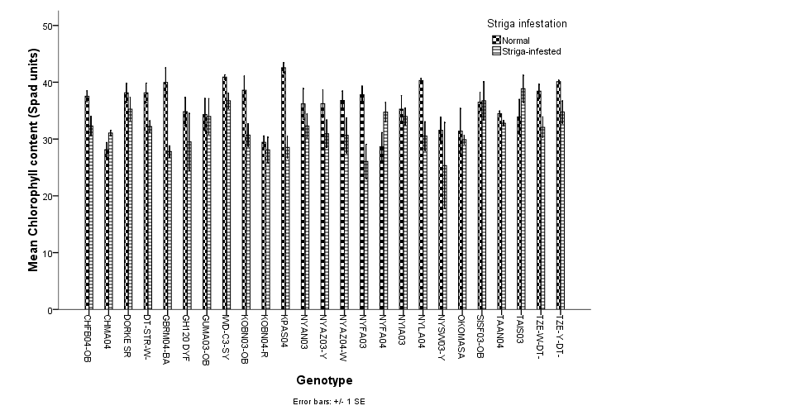
Figure 1: Changes in chlorophyll content of the genotypes during screening under greenhouse conditions in 2012

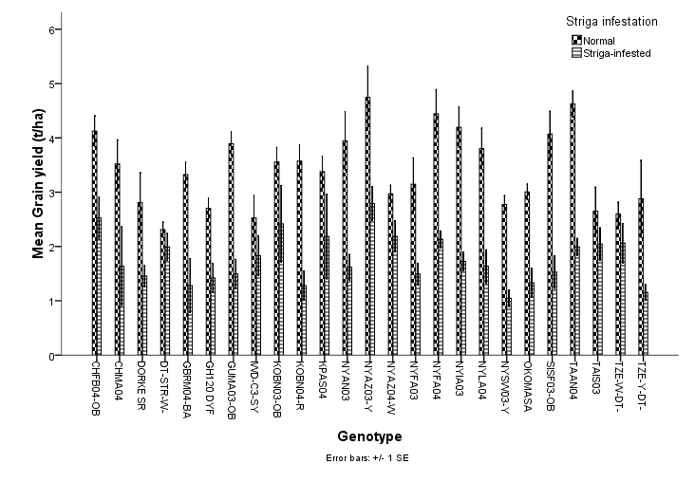
Figure 2: Changes in grain yield of the genotypes during screening in the 2013 cropping season
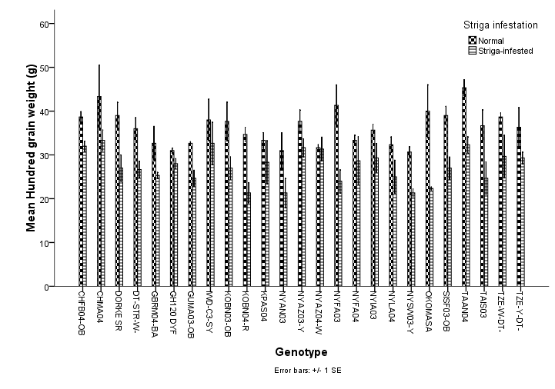
Figure 3: Change in hundred – grain weight of the genotypes during screening in 2013 cropping season

